Project: Digital Banking System

Front End Development

Developed a client based modularized angular application, which allow users to register, login, use the services and checkout. It is a single page application where only part of the page is loaded not completely

Frontend of our project:

The Login screen looks as below:

Once the application is loaded the first screen appears as below

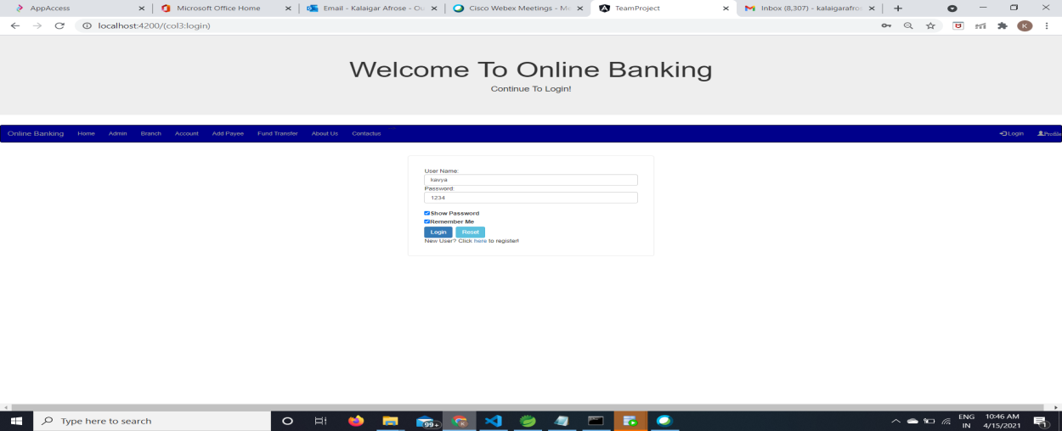

From the above you screen you must be able to perform 3 activities

1. Go to Registration screen when you click on Register link
2. Go to Home screen when you login successfully after entering valid username & password fetched from some temporary variable (this variable will store all the user details entered as a database temporarily)
3. Redirect back to same login screen if username & password are not matching

The Registration screen looks as below:

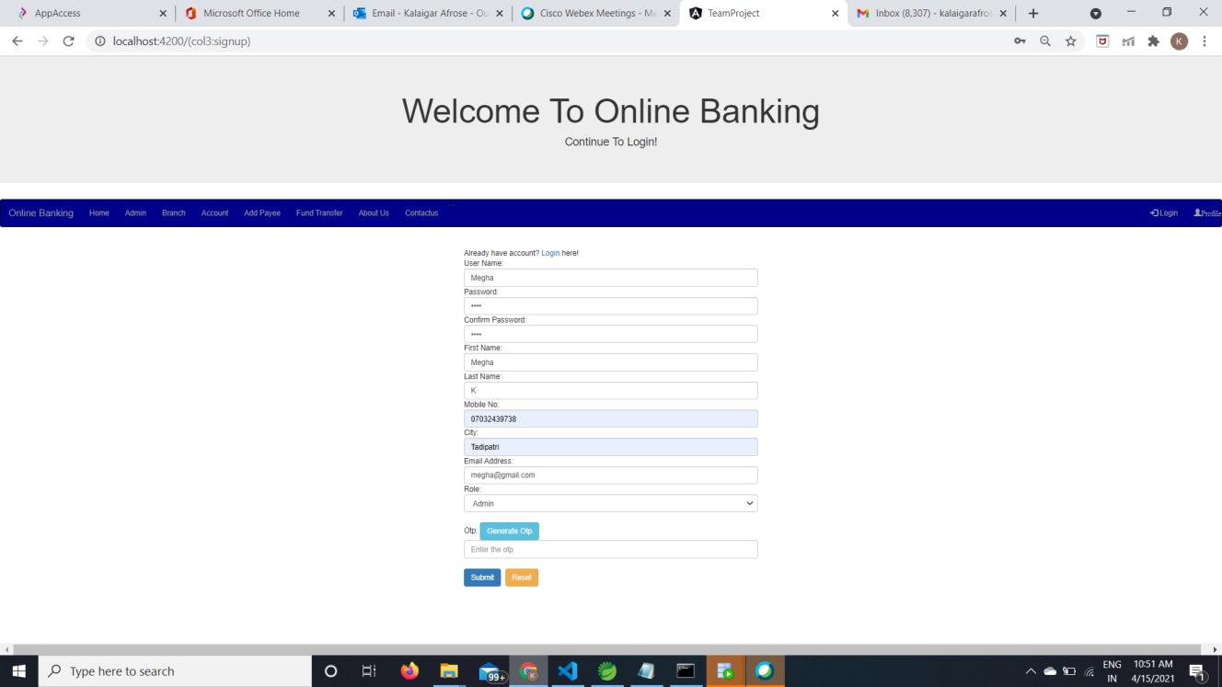

Enter all the details mandatorily and hit store which redirects back to login screen, but data will be stored in a temporary variable in your application before coming to the login screen.

The Home screen looks as below:

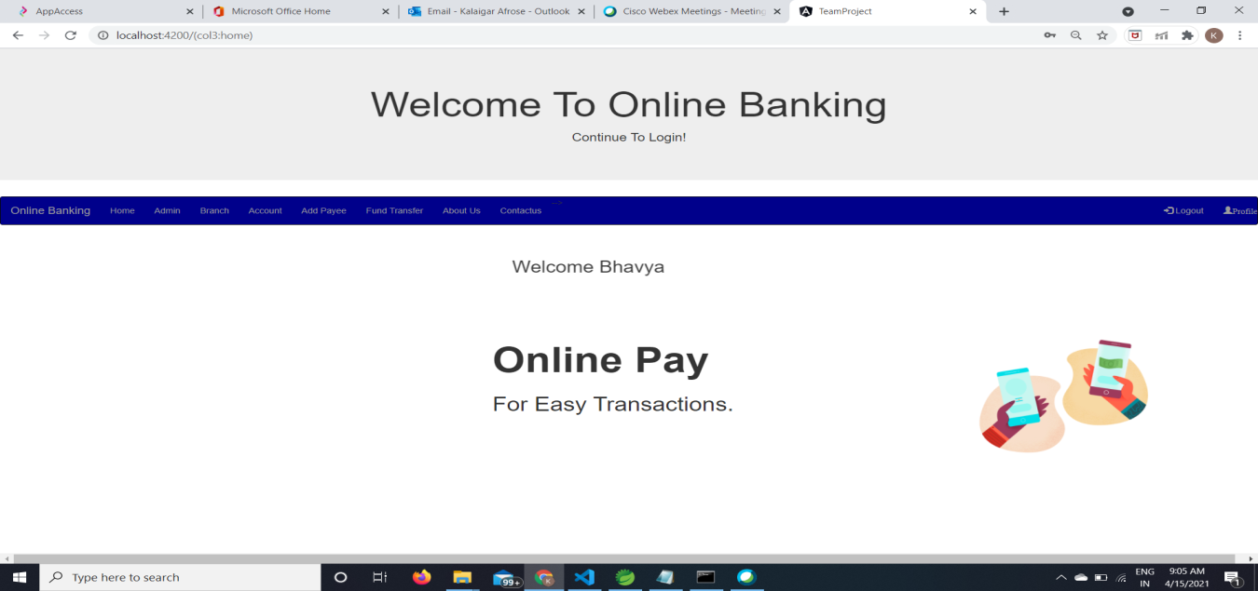

User can know how many branches are there under this bank and he can also know the balance in his account. He can also transfer the money to different accounts. Here the user can access any of the menu items except Admin. Because only Admin can view all the transactions made by the user. User is not allowed to add the branch. Only Admin can add, modify, delete the branches.

The Admin screen looks as below:

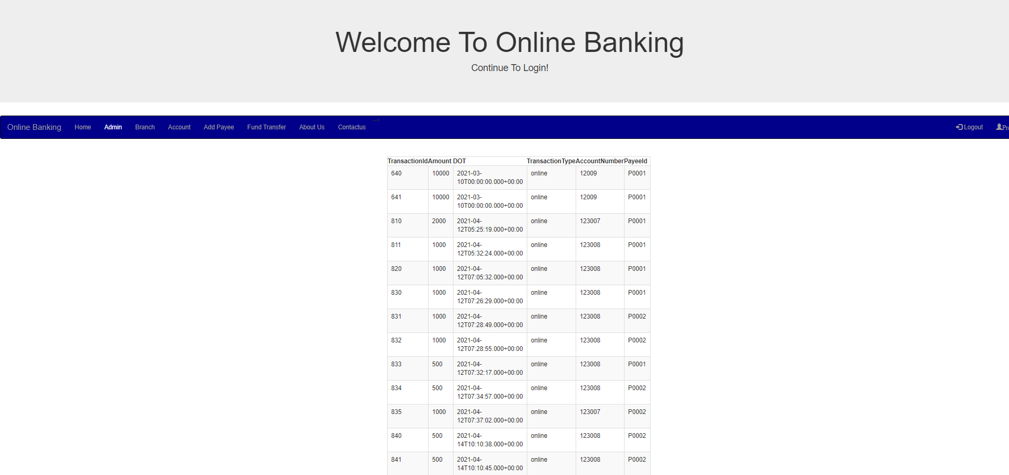

Admin can view the transactions.

The Branch screen looks as below:

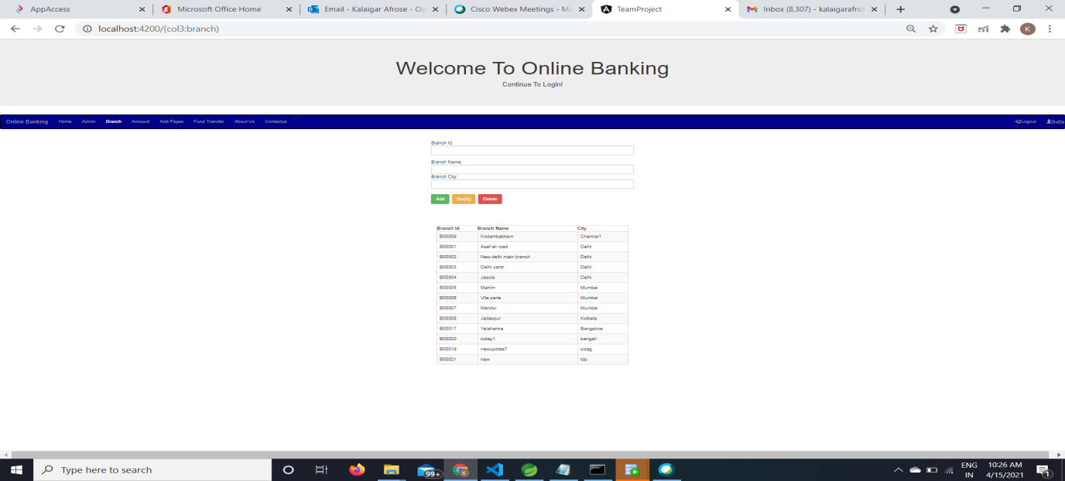

Admin can add, modify or delete the branches. But user can only view the branches under the respective bank.

The Account screen looks as below:

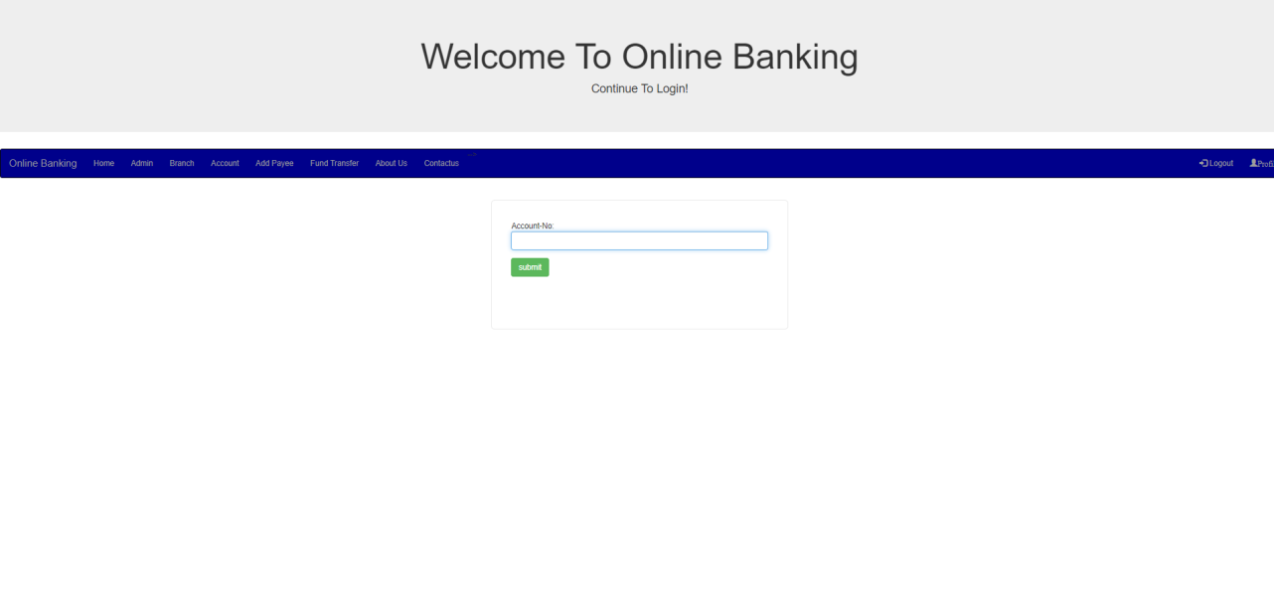

When you click on submit button it will display the account details.

The Payee screen looks as below:

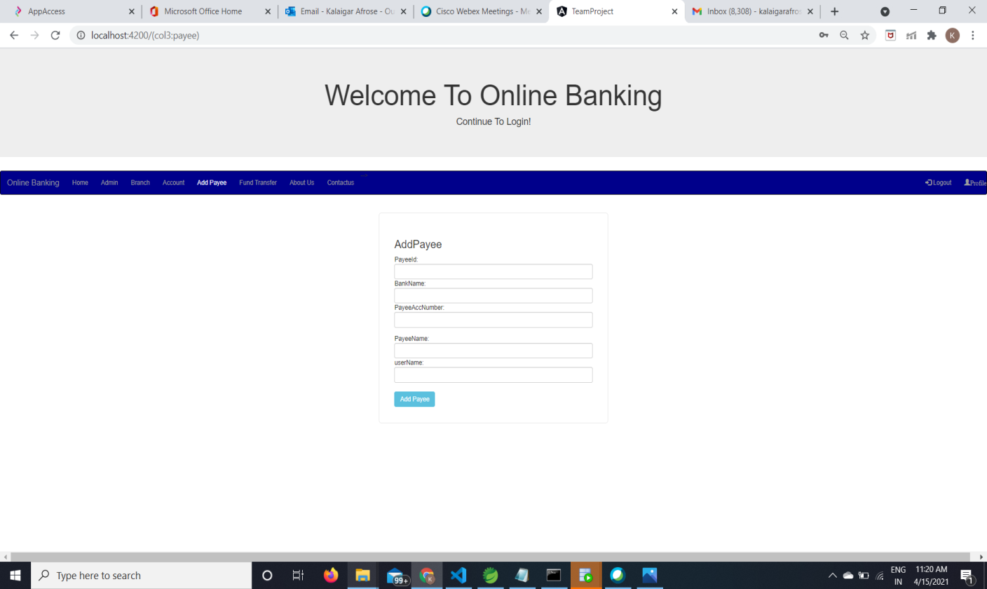

When you click on add payee button it will add the payee account details.

The transfer screen looks as below:

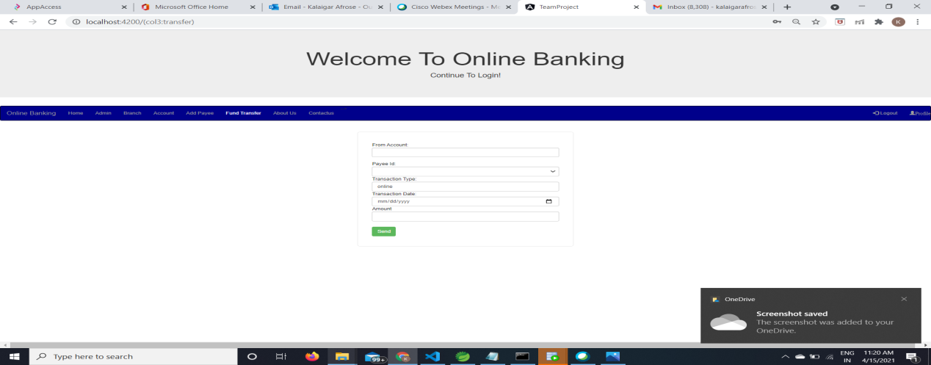

The About us screen looks as below:

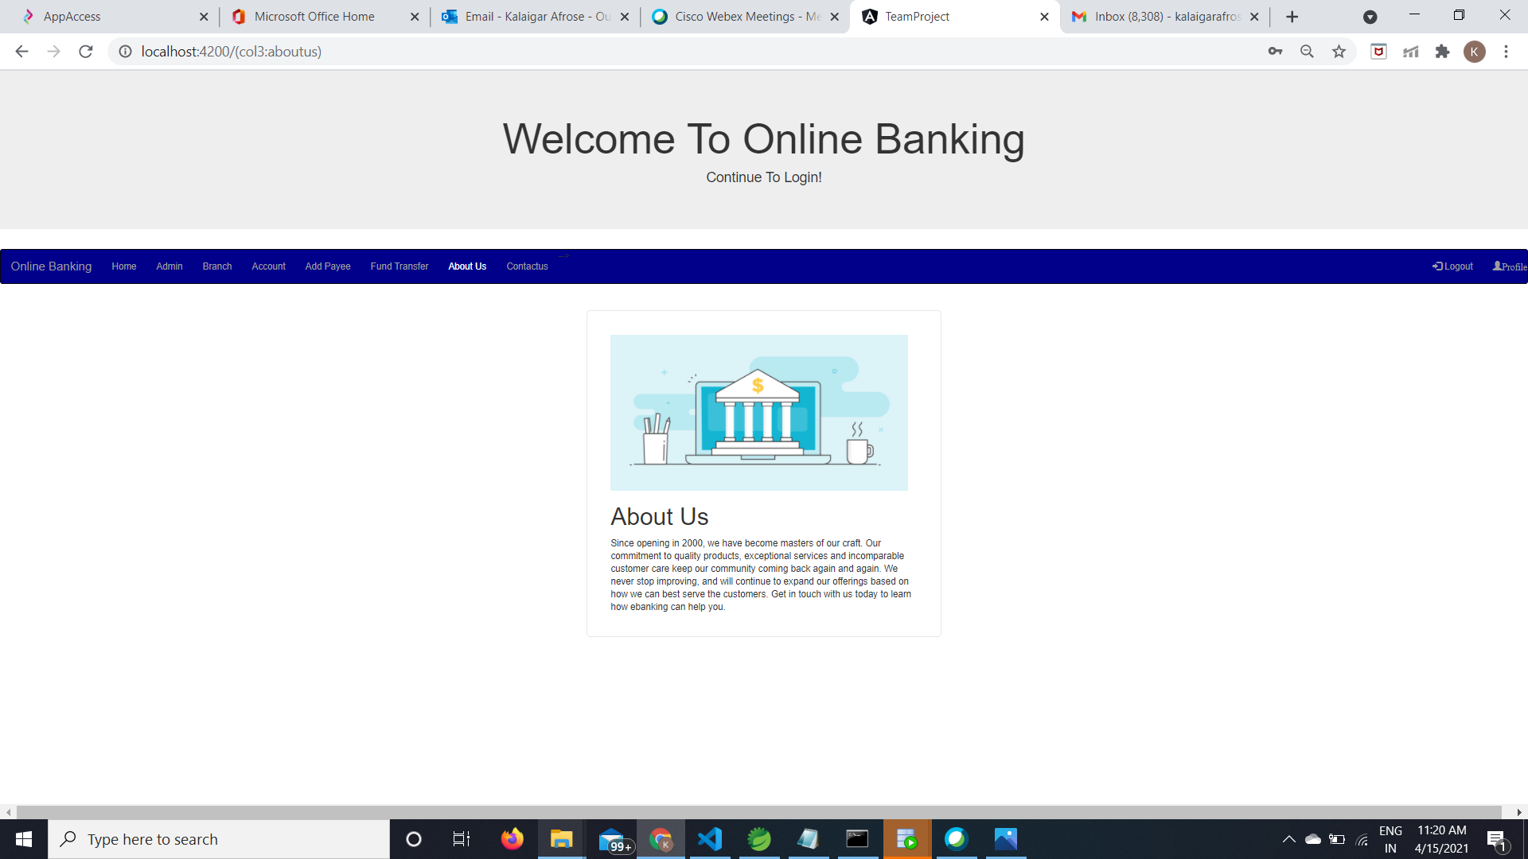

The Contact us screen looks as below:

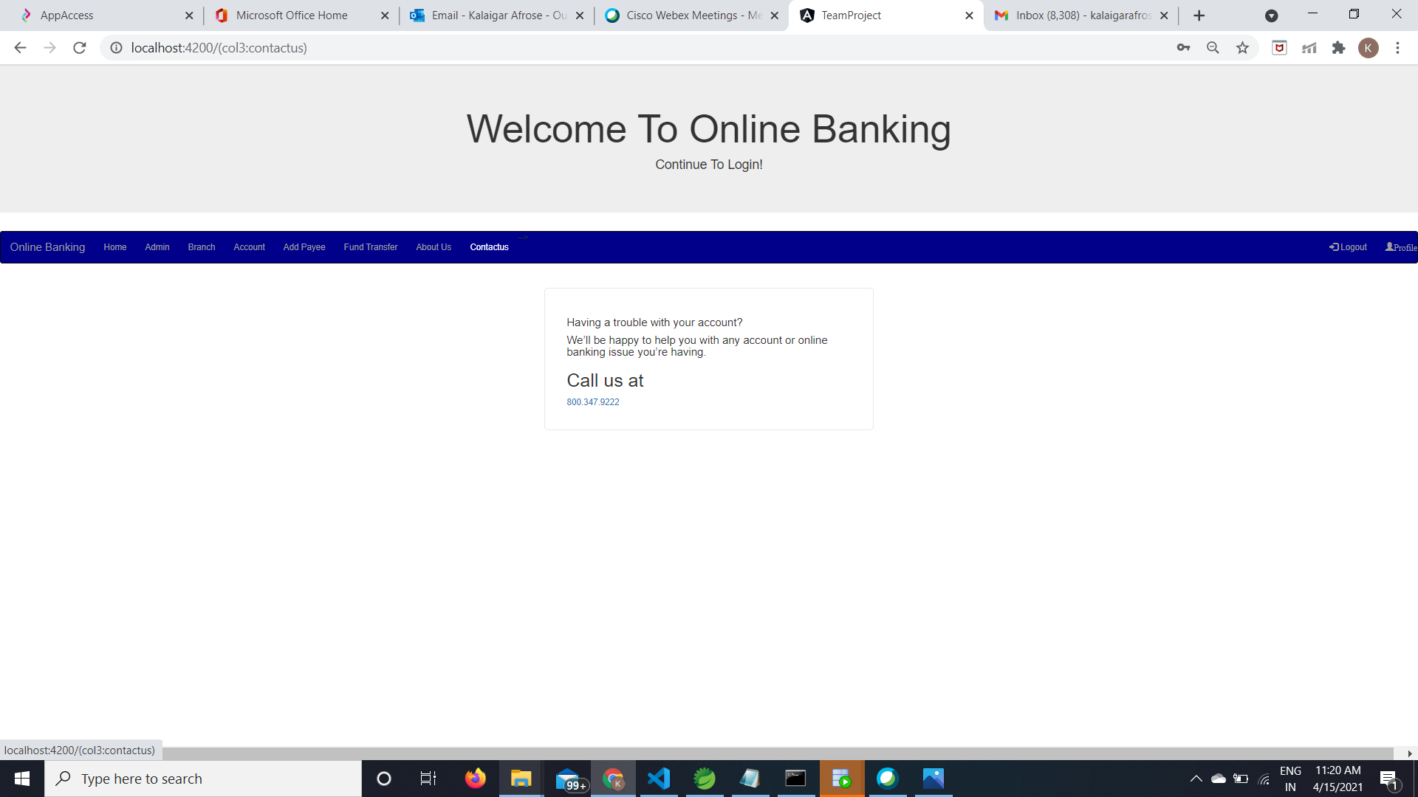

Validations

Register validations:

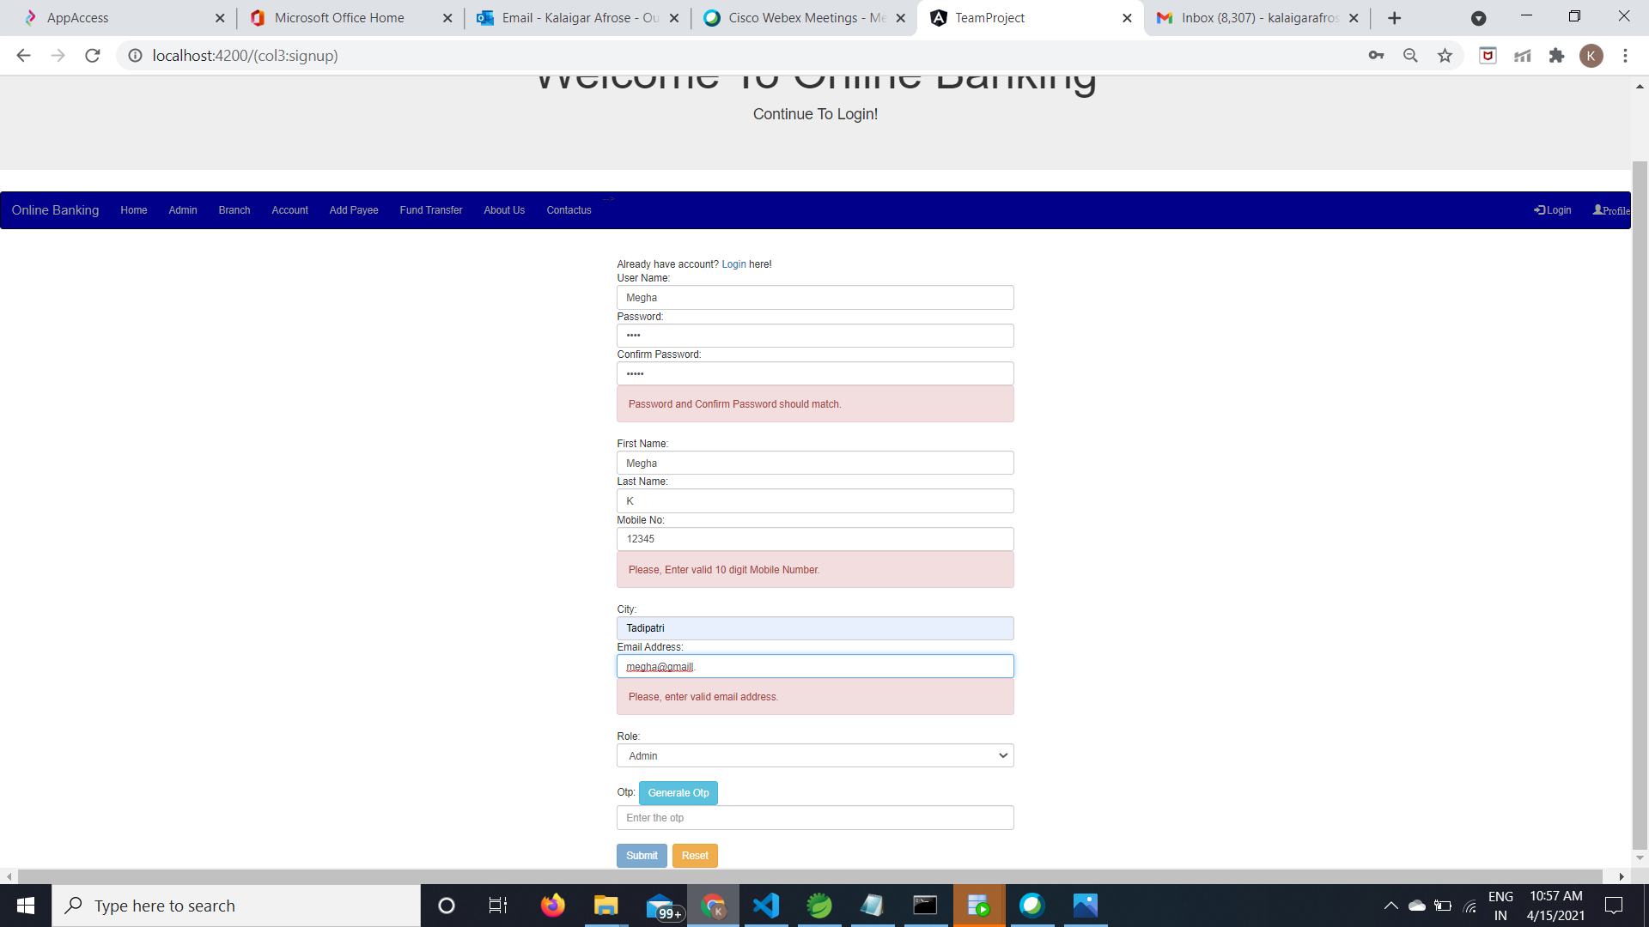

Login validations

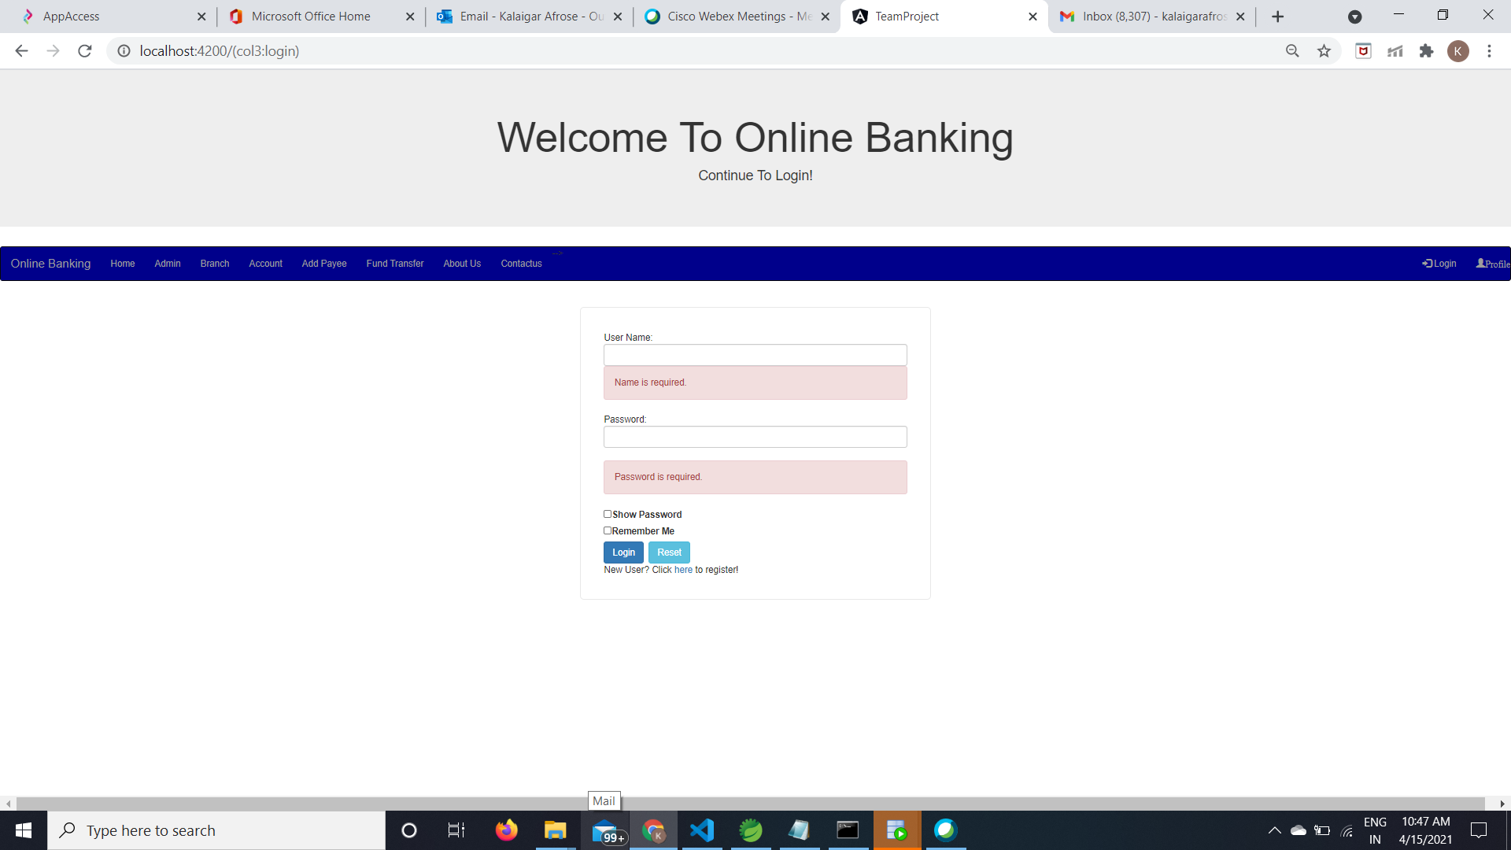

Account validations

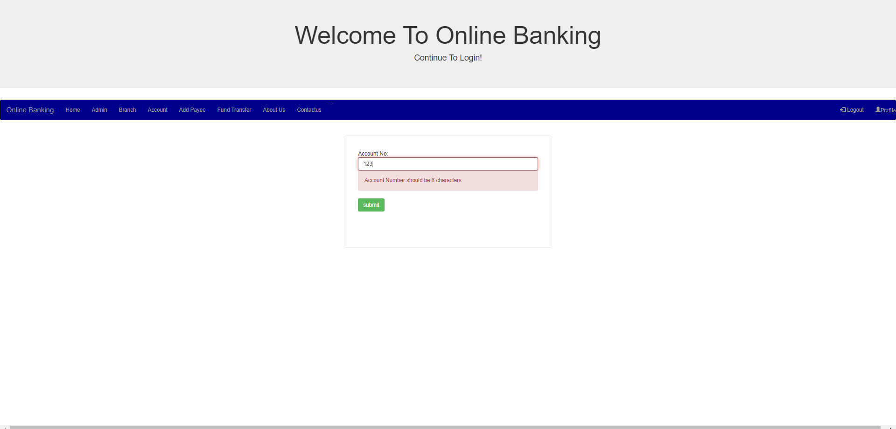

Payee validations

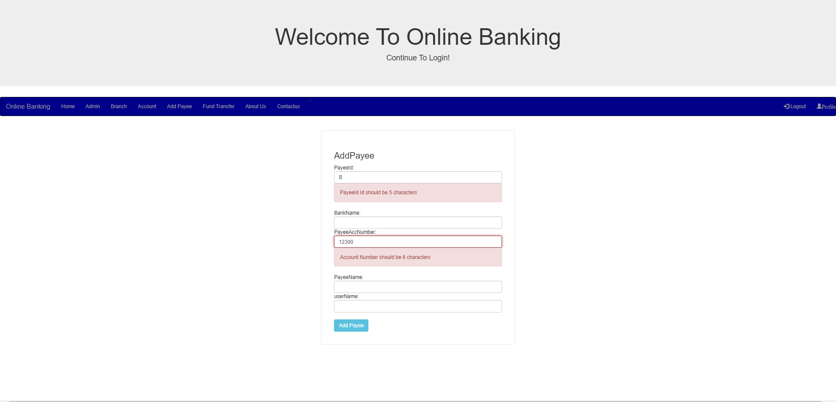

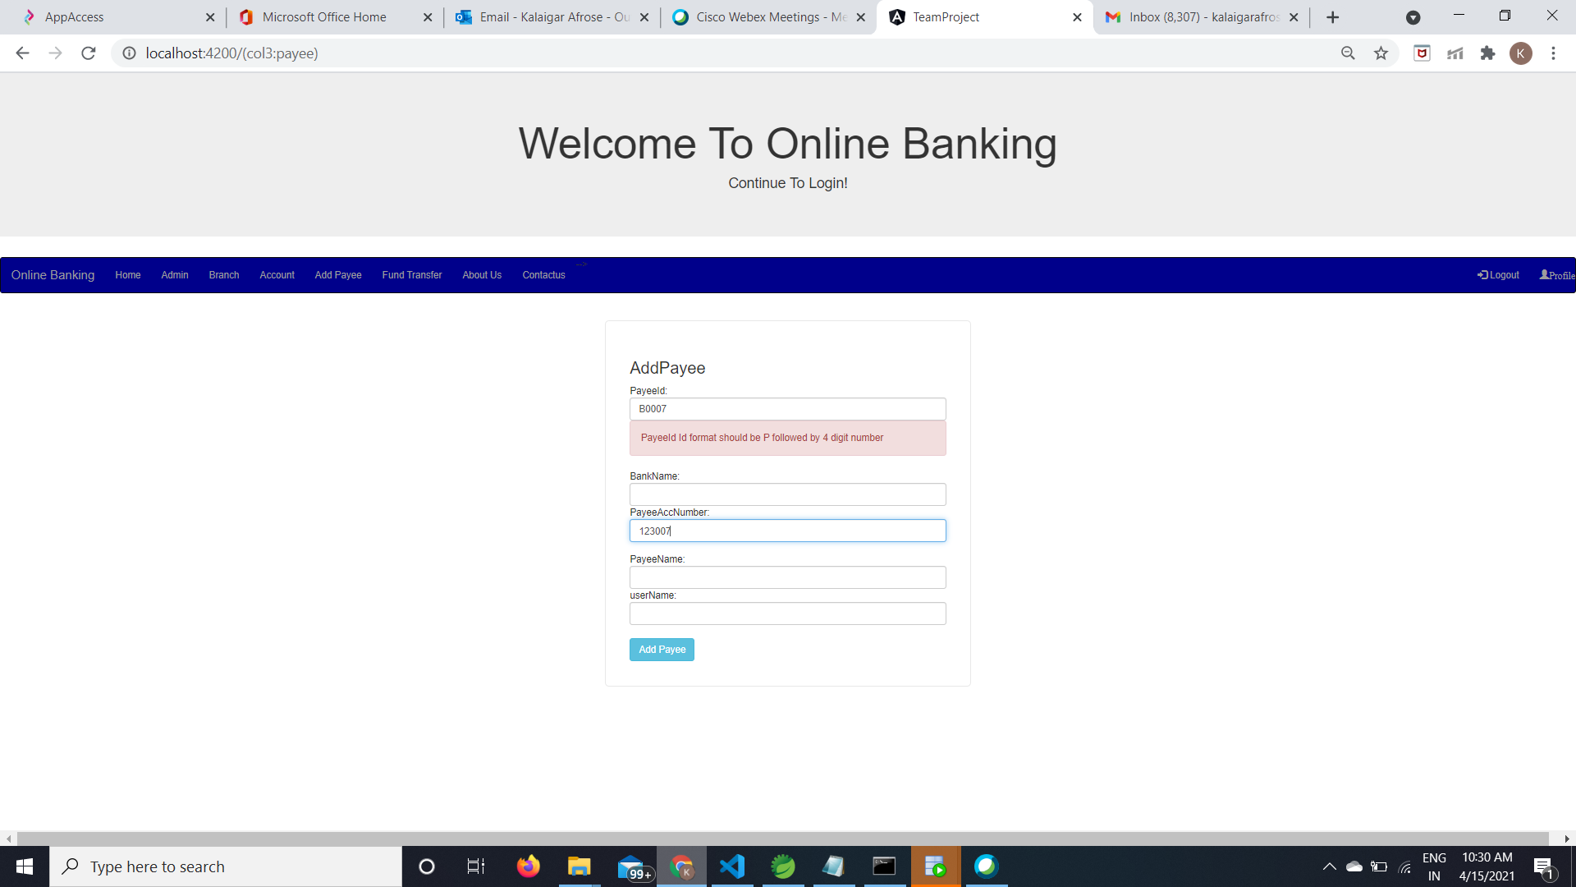

Fund transfer validations

